Supplementary Information (SI)

Time (min) | 7 mg | 8 mg | 9 mg | 10 mg | 20 mg | 30 mg | 40 mg | 50 mg | 60 mg | 70 mg | 80 mg | 90 mg | 100 mg | 200 mg
0 | 1 | 1 | 1 | 1 | 1 | 1 | 1 | 1 | 1 | 1 | 1 | 1 | 1 | 1
10 | 0.658 | 0.573 | 0.406 | 0.379 | 0.429 | 0.424 | 0.460 | 0.284 | 0.165 | 0.151 | 0.277 | 0.189 | 0.047 | 0.018
20 | 0.622 | 0.558 | 0.355 | 0.357 | 0.358 | 0.393 | 0.380 | 0.323 | 0.146 | 0.132 | 0.284 | 0.165 | 0.035 | 0.016
30 | 0.586 | 0.543 | 0.338 | 0.343 | 0.342 | 0.357 | 0.318 | 0.305 | 0.125 | 0.110 | 0.228 | 0.131 | 0.028 | 0.013
40 | 0.566 | 0.515 | 0.323 | 0.338 | 0.298 | 0.333 | 0.282 | 0.295 | 0.118 | 0.100 | 0.192 | 0.119 | 0.023 | 0.010
50 | 0.558 | 0.507 | 0.318 | 0.328 | 0.312 | 0.333 | 0.205 | 0.272 | 0.106 | 0.094 | 0.163 | 0.107 | 0.021 | 0.008
60 | 0.535 | 0.482 | 0.301 | 0.318 | 0.309 | 0.300 | 0.205 | 0.217 | 0.097 | 0.078 | 0.143 | 0.080 | 0.019 | 0.005
70 | 0.510 | 0.441 | 0.28 | 0.306 | 0.298 | 0.272 | 0.179 | 0.186 | 0.090 | 0.072 | 0.126 | 0.060 | 0.016 | 0.005
80 | 0.507 | 0.423 | 0.269 | 0.294 | 0.258 | 0.257 | 0.169 | 0.155 | 0.082 | 0.056 | 0.119 | 0.051 | 0.014 | 0.002
90 | 0.497 | 0.397 | 0.257 | 0.269 | 0.244 | 0.227 | 0.156 | 0.147 | 0.078 | 0.034 | 0.092 | 0.046 | 0.009 | 0.002
100 | 0.471 | 0.372 | 0.232 | 0.245 | 0.222 | 0.206 | 0.138 | 0.113 | 0.068 | 0.025 | 0.087 | 0.041 | 0.007 | 0.002
110 | 0.446 | 0.357 | 0.225 | 0.225 | 0.206 | 0.196 | 0.128 | 0.108 | 0.059 | 0.015 | 0.072 | 0.038 | 0.004 | 0.002
120 | 0.433 | 0.326 | 0.196 | 0.181 | 0.176 | 0.166 | 0.107 | 0.090 | 0.033 | 0.009 | 0.058 | 0.034 | 0.002 | 0.002
Supplementary Table 1. Cₜ/C₀ values calculated from absorbance at various catalyst dosages

Supplementary Table 2. Cₜ/C₀ values at various initial dye concentrations
Time(min) | 20 ppm | 30 ppm | 40 ppm | 50 ppm | 60 ppm | 70 ppm | 80 ppm
0 | 1 | 1 | 1 | 1 | 1 | 1 | 1
10 | 0.151 | 0.226 | 0.306 | 0.502 | 0.506 | 0.704 | 0.717
20 | 0.132 | 0.197 | 0.298 | 0.495 | 0.485 | 0.671 | 0.709
30 | 0.110 | 0.171 | 0.280 | 0.465 | 0.477 | 0.669 | 0.705
40 | 0.100 | 0.153 | 0.271 | 0.442 | 0.466 | 0.664 | 0.690
50 | 0.094 | 0.145 | 0.233 | 0.435 | 0.457 | 0.656 | 0.678
60 | 0.078 | 0.118 | 0.225 | 0.427 | 0.455 | 0.650 | 0.664
70 | 0.072 | 0.113 | 0.209 | 0.424 | 0.443 | 0.641 | 0.647
80 | 0.056 | 0.100 | 0.188 | 0.386 | 0.432 | 0.596 | 0.618
90 | 0.031 | 0.089 | 0.160 | 0.373 | 0.423 | 0.562 | 0.607
100 | 0.015 | 0.079 | 0.152 | 0.356 | 0.413 | 0.549 | 0.603
110 | 0.012 | 0.052 | 0.147 | 0.350 | 0.388 | 0.500 | 0.592
120 | 0.009 | 0.039 | 0.121 | 0.298 | 0.333 | 0.483 | 0.577

Supplementary Table 3. Pseudo-first-order kinetic data at various initial dye concentrations
Time(min) | 20 ppm | 30 ppm | 40 ppm | 50 ppm | 60 ppm | 70 ppm | 80 ppm
0 | 0 | 0 | 0 | 0 | 0 | 0 | 0
10 | 1.887 | 1.483 | 1.181 | 0.689 | 0.679 | 0.349 | 0.331
20 | 2.021 | 1.620 | 1.208 | 0.702 | 0.722 | 0.398 | 0.342
30 | 2.203 | 1.763 | 1.269 | 0.764 | 0.738 | 0.401 | 0.349
40 | 2.293 | 1.877 | 1.305 | 0.815 | 0.762 | 0.408 | 0.369
50 | 2.357 | 1.930 | 1.453 | 0.831 | 0.781 | 0.420 | 0.388
60 | 2.540 | 2.130 | 1.488 | 0.850 | 0.786 | 0.430 | 0.408
70 | 2.623 | 2.176 | 1.563 | 0.856 | 0.813 | 0.443 | 0.434
80 | 2.868 | 2.299 | 1.669 | 0.950 | 0.838 | 0.516 | 0.481
90 | 3.456 | 2.411 | 1.828 | 0.985 | 0.859 | 0.576 | 0.498
100 | 4.149 | 2.536 | 1.879 | 1.030 | 0.883 | 0.598 | 0.504
110 | 4.372 | 2.941 | 1.912 | 1.049 | 0.944 | 0.691 | 0.523
120 | 4.660 | 3.229 | 2.105 | 1.208 | 1.098 | 0.727 | 0.549

Supplementary Table 4. Cₜ/C₀ values for the effect of temperature on RB 194 degradation
Time (min) | 20 °C | 30 °C | 40 °C | 50 °C | 60 °C | 70 °C
0 | 1 | 1 | 1 | 1 | 1 | 1
10 | 0.151 | 0.194 | 0.263 | 0.315 | 0.500 | 0.552
20 | 0.132 | 0.168 | 0.260 | 0.286 | 0.426 | 0.497
30 | 0.110 | 0.155 | 0.242 | 0.260 | 0.394 | 0.484
40 | 0.100 | 0.142 | 0.236 | 0.257 | 0.373 | 0.471
50 | 0.094 | 0.139 | 0.226 | 0.247 | 0.355 | 0.452
60 | 0.078 | 0.129 | 0.213 | 0.239 | 0.342 | 0.434
70 | 0.072 | 0.116 | 0.197 | 0.226 | 0.328 | 0.421
80 | 0.056 | 0.103 | 0.165 | 0.213 | 0.323 | 0.407
90 | 0.031 | 0.101 | 0.157 | 0.207 | 0.315 | 0.400
100 | 0.015 | 0.082 | 0.136 | 0.197 | 0.286 | 0.394
110 | 0.012 | 0.064 | 0.118 | 0.178 | 0.268 | 0.381
120 | 0.009 | 0.046 | 0.092 | 0.157 | 0.244 | 0.368

Supplementary Table 5. Cₜ/C₀ values calculated from absorbance at different pH values
Time (min) | 3 | 4 | 5 | 6 | 8 | 9 | 10 | 11
0 | 1 | 1 | 1 | 1 | 1 | 1 | 1 | 1
10 | 0.422 | 0.351 | 0.156 | 0.062 | 0.862 | 0.698 | 0.875 | 0.964
20 | 0.405 | 0.325 | 0.151 | 0.058 | 0.844 | 0.660 | 0.763 | 0.941
30 | 0.387 | 0.315 | 0.146 | 0.051 | 0.836 | 0.640 | 0.670 | 0.882
40 | 0.366 | 0.306 | 0.142 | 0.046 | 0.831 | 0.630 | 0.662 | 0.857
50 | 0.328 | 0.293 | 0.139 | 0.036 | 0.806 | 0.628 | 0.622 | 0.839
60 | 0.315 | 0.282 | 0.133 | 0.034 | 0.739 | 0.618 | 0.612 | 0.829
70 | 0.307 | 0.279 | 0.128 | 0.029 | 0.727 | 0.582 | 0.598 | 0.808
80 | 0.289 | 0.263 | 0.121 | 0.025 | 0.635 | 0.572 | 0.582 | 0.721
90 | 0.275 | 0.249 | 0.110 | 0.022 | 0.584 | 0.552 | 0.572 | 0.701
100 | 0.257 | 0.242 | 0.101 | 0.018 | 0.561 | 0.542 | 0.477 | 0.673
110 | 0.249 | 0.231 | 0.096 | 0.014 | 0.497 | 0.532 | 0.447 | 0.655
120 | 0.231 | 0.208 | 0.079 | 0.009 | 0.446 | 0.421 | 0.401 | 0.604

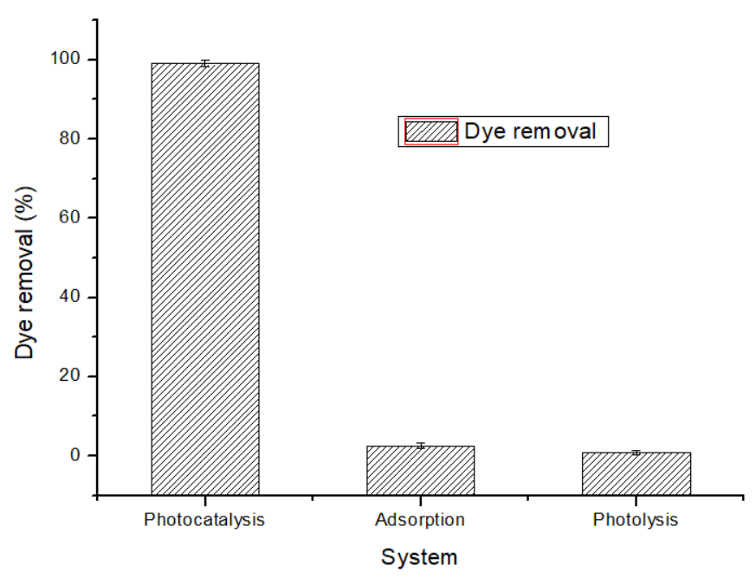
Supplementary Fig. 1: Comparison of photocatalysis, adsorption and photolysis (catalyst dose 70 mg)

Supplementary Table 6. Point-of-zero-charge data obtained by the salt-addition method
Sr. No | pHi | pHf | ΔpH (pHf − pHi)
1 | 3.54 | 3.9 | 0.36
2 | 4.00 | 6.27 | 2.27
3 | 5.06 | 8.26 | 3.20
4 | 6.14 | 7.34 | 1.20
5 | 7.07 | 9.84 | 2.77
6 | 8.91 | 8.98 | 0.07
7 | 8.96 | 8.79 | -0.17
8 | 10.38 | 8.36 | -2.02
9 | 11.00 | 10.36 | -0.64

Supplementary Table 7. Absorbance values obtained in the presence of different scavengers
Time (min) | Ascorbic acid | K₂Cr₂O₇ | DMSO | EDTA
0 | 0.369 | 0.391 | 0.267 | 0.267
10 | 0.019 | 0.085 | 0.133 | 0.149
20 | 0.017 | 0.062 | 0.08 | 0.188
30 | 0.014 | 0.066 | 0.062 | 0.211
40 | 0.013 | 0.059 | 0.046 | 0.228
50 | 0.008 | 0.051 | 0.039 | 0.244
60 | 0.005 | 0.043 | 0.026 | 0.256
70 | 0.004 | 0.033 | 0.014 | 0.258
80 | 0.003 | 0.03 | 0.004 | 0.274
90 | 0.002 | 0.025 | 0 | 0.259
100 | 0.001 | 0.02 | 0 | 0.259
110 | 0.001 | 0.015 | 0 | 0.355
120 | 0 | 0.01 | 0 | 0.265

Supplementary Table 8. Cₜ/C₀ values obtained in the presence of different scavengers
Time (min) | Ascorbic acid | K₂Cr₂O₇ | DMSO | EDTA
0 | 1 | 1 | 1 | 1
10 | 0.0515 | 0.217391 | 0.498127 | 0.558052
20 | 0.0461 | 0.158568 | 0.299625 | 0.70412
30 | 0.0379 | 0.168798 | 0.23221 | 0.790262
40 | 0.035230352 | 0.150895 | 0.172285 | 0.853933
50 | 0.021680217 | 0.130435 | 0.146067 | 0.913858
60 | 0.013550136 | 0.109974 | 0.097378 | 0.958801
70 | 0.010840108 | 0.084399 | 0.052434 | 0.966292
80 | 0.008130081 | 0.076726 | 0.014981 | 1.026217
90 | 0.005420054 | 0.063939 | 0 | 0.970037
100 | 0.002710027 | 0.051151 | 0 | 0.970037
110 | 0.002710027 | 0.038363 | 0 | 1.329588
120 | 0 | 0.025575 | 0 | 0.992509

Supplementary Table 9. Reusability results over five photocatalytic cycles
Number of Cycles | (%) Degradation
Cycle 1 | 86.82
Cycle 2 | 84.31
Cycle 3 | 81.50
Cycle 4 | 77.57
Cycle 5 | 71.53

Supplementary Table 10. Tentative GC–MS library-based assignments of compounds detected during UV-assisted treatment of RB 194.
Peak | R.Time | I.Time | F.Time | A | A % | H | H  % | A/H | Mark | Name
1 | 1.260 | 1.220 | 1.290 | 50583 | 2.40 | 16918 | 2.37 | 2.99 |  | water
2 | 1.319 | 1.290 | 1.425 | 196179 | 93.1 | 58710 | 82.1 | 3.34 | V | water
3 | 1.512 | 1.500 | 1.545 | 74116 | 3.52 | 94470 | 13.2 | 0.78 | V | trichloromethane
4 | 10.128 | 10.110 | 10.150 | 8655 | 0.41 | 7885 | 1.10 | 1.10
5 | 10.609 | 10.585 | 10.630 | 11167 | 9.53 | 8100 | 1.13 | 1.30
 |  |  |  | 210631 | 100 | 71448 | 100

